**Growing an Argumentative Thesis**

{Prompt: Discuss and form a researched argument on a commonly debated issue in the media.}

**Beginning thesis:** I hate genetically modified food.

**Tips for Growth!** Make sure you pay attention to what the prompt is asking! Look for helpful keywords like a detective looks for clues.  If the prompt asks you to reflect on your personal beliefs and values, this may be the start of an appropriate thesis.  However, if you're being asked to argue a position, your personal opinions or feelings on the topic do not form a proper thesis.



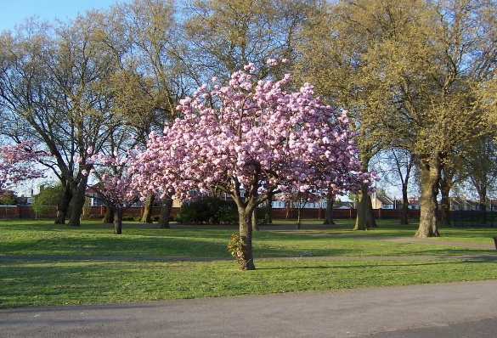

**Budding thesis:** Genetically modified food is food that has been modified genetically.

**Tips for Growth!** The statement above is a fact. If you're being asked to argue a position, your thesis should be a statement that someone else could potentially disagree with or argue about. If you're not sure whether your thesis is arguable, try asking questions, such as "Is this a statement that can be challenged or questioned?  Is this something that a reader could contradict?”

**Blooming thesis:** Genetically modified food is unhealthy.

**Tips for Growth!** While this thesis gives readers a broad understanding of what argument the writer is going to make, it should be a bit narrower in the actual essay. The argument could be strengthened with more specific wording and more information. Without a specific thesis, the reader may have questions such as, "Are the modified organisms themselves unhealthy, or is it unhealthy for other organisms to eat them?” that should ideally be answered in the thesis.

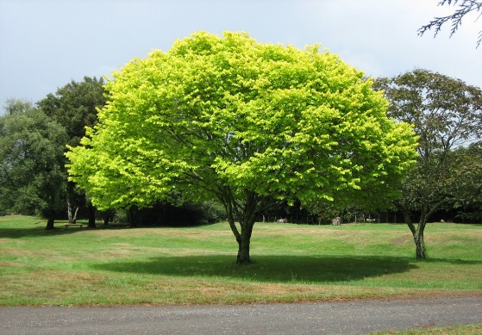

**Beautiful Thesis!**  While there may be economic benefits to growing genetically modified crops, there are negative health consequences for the people who consume them and for the farmers who produce them.

This thesis is a great first step to writing an essay. It addresses the prompt, provides an argument, and includes wording that is clear and precise. The thesis provides an outline of what the writer will be talking about throughout the remainder of the paper.

