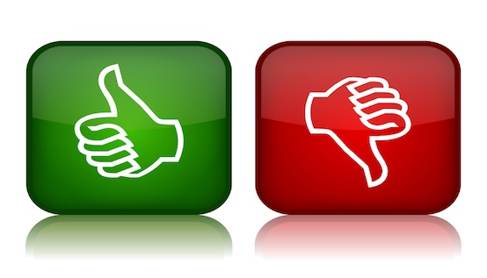

**Evaluating Credibility of Sources**

**Author**

* Degree
* College
* Current career
* Past publications
* Bias
* Cited by other authors
* Are the sources that the author used credible?

Determine your author’s credentials. If an author cannot be found, check out the publisher for credibility.

**Date**

* Science
* Humanities

An older source may work if your topic is in the humanities. However, if your topic is related to Science, a more recent source is desired.

**Intended Audience**

* Depth
* Too specialized
* Too general
* Tone

Look at each of the following categories and decide if it fits your intended audience

**Publisher**

* University Press
* Peer reviewed journals
* Newspaper
* Government program
* Well-known media outlet

Publications should come from a reputable institution.

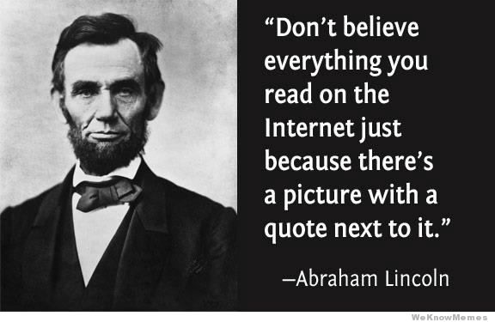

**Presentation**

* Accurate grammar, spelling, and punctuation
* Structure: organization of information
* Style: font and size
* Design: colors and backgrounds

The website’s credibility can be reflected in its easy-to-use design so that users can assess the information with ease.

**Purpose of Site**

* Public Services
* General Info
* Persuasion
* Personal hobby
* Commercial selling

If the purpose of the site is different than the reason you are using that site, you need to be careful because the information could be slanted/biased based on the intended purpose.

**Evaluating the Credibility of Websites**

**Verifiable**

* Can the information be verified with other sources (i.e. encyclopedia)?
* Is it as good as a resource in the library?

The information in the website should be confirmed through other reputable sources.

**References**

* Does the information in the website have footnotes, references, and reputable links?

The author should use credible resources that have been properly cited.

**Ending of Website Address**

* Gov: government
* Edu: educational
* Com: commercial
* Org: organization
* Net: network
* Mil: military

The website’s ending can give you insight as to the purpose the site and can indicate a bias about the information and the way it is presented.