Comma Splice
- A comma splice occurs when two complete sentences are joined by a comma, and there is no conjunction present.

- A complete sentence consists of a subject and a verb.

- Example:
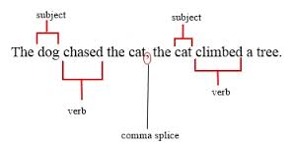
Run-on Sentence

- Run-on sentence involves two complete sentences merged together without any punctuation.

- Example: You wore a lovely hat it was your only defense.
Ways to correct comma splice and run-on sentences | Example
- Just add one of the FANBOYS coordinating conjunctions  For  And  Nor  But  Or  Yet  So | The dog chased the cat, so the cat climbed a tree.  You wore a lovely hat, for it was your only defense.
- Change the comma to a semicolon | The dog chased the cat; the cat climbed a tree.  You wore a lovely hat; it was your only defense.
- Make each clause a separate sentence | The dog chased the cat. The cat climbed a tree.  You wore a lovely hat. It was your only defense.
- Add a subordinating conjunction  although as/as if once  even though so that while  provided that because until  after in order to when  even if unless where  since before why  whereas whether whereas | The dog chased the cat until the cat climbed a tree.  You wore a lovely hat because it was your only defense.

